# Resonance Structures, Formal Charges, and Polarity

Troy University Chemistry Faculty

[Creative Commons License](http://creativecommons.org/licenses/by-sa/4.0/) Licensed under a [Creative Commons Attribution-ShareAlike 4.0 International License](http://creativecommons.org/licenses/by-sa/4.0/).

## Introduction

Lewis structures are models representing covalent bonding between atoms. These structures use dots around atoms to signify electrons and lines to signify bonds between atoms. Lewis structures that differ only in the arrangement of electrons are called resonance structures. The most likely Lewis structures is determined using formal charge, which is the charge of an atom in a molecule, assuming that electrons in a chemical bond are shared equally between atoms. Below are resonance structures of the carbonate anion, CO32-.

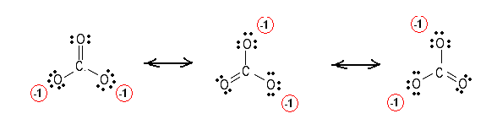

## Procedure

For each species in the worksheet:

1. Draw a Lewis structure. Since this lab is about resonance, nearly every structure will have a double bond.
2. Determine the formal charges on each atom of the Lewis structure. The formal charge are calculated using the formula:
$$FC=\# valence electrons-(\# nonbonding electrons+½ \# bonding electrons)$$

3. Draw a structure with the most favorable formal charges. This may involve moving the double bond around, or converting a single bond to a double bond, or converting something like X=M=X to X–M≡X or X≡M–X. The dominant structure has

a) the lowest formal charges, and

b) any negative formal charges on the most electronegative element.

Atoms in row 3 and beyond can have more than an octet. For such atoms, consider converting single bonds to double bonds to lower the formal change.

1. Draw all possible resonance structures for this most likely structure.
2. Include formal charges on all of your structures. Formal charges of 0 do not need to be shown.
3. Identify the electronic and molecular geometry. The tables on the following pages may help.
4. Construct a model of the probable structure using the model kit and show to the instructor.
5. Draw a sketch of the model. Your sketches should have bonds in the plane of the paper drawn as plain lines, bonds coming out of the paper drawn as wedges, and bonds going behind the paper drawn as dashes. (The attached table of VSEPR geometries has examples you can use.)
6. In the column labeled polarity, indicate if the molecule is polar or nonpolar. If everything attached to the central atom is the same, it is nonpolar; otherwise, it is polar. For example, CH4 is tetrahedral and non-polar; H2O has two lone pairs and two bonds, the things around it are not identical, so it is polar. Polar and nonpolar can even be assigned to ions.
7. Wait to leave until your instructor has finished checking your report to ensure that you understand everything, and that you get full credit on this lab report.

Electronegativity

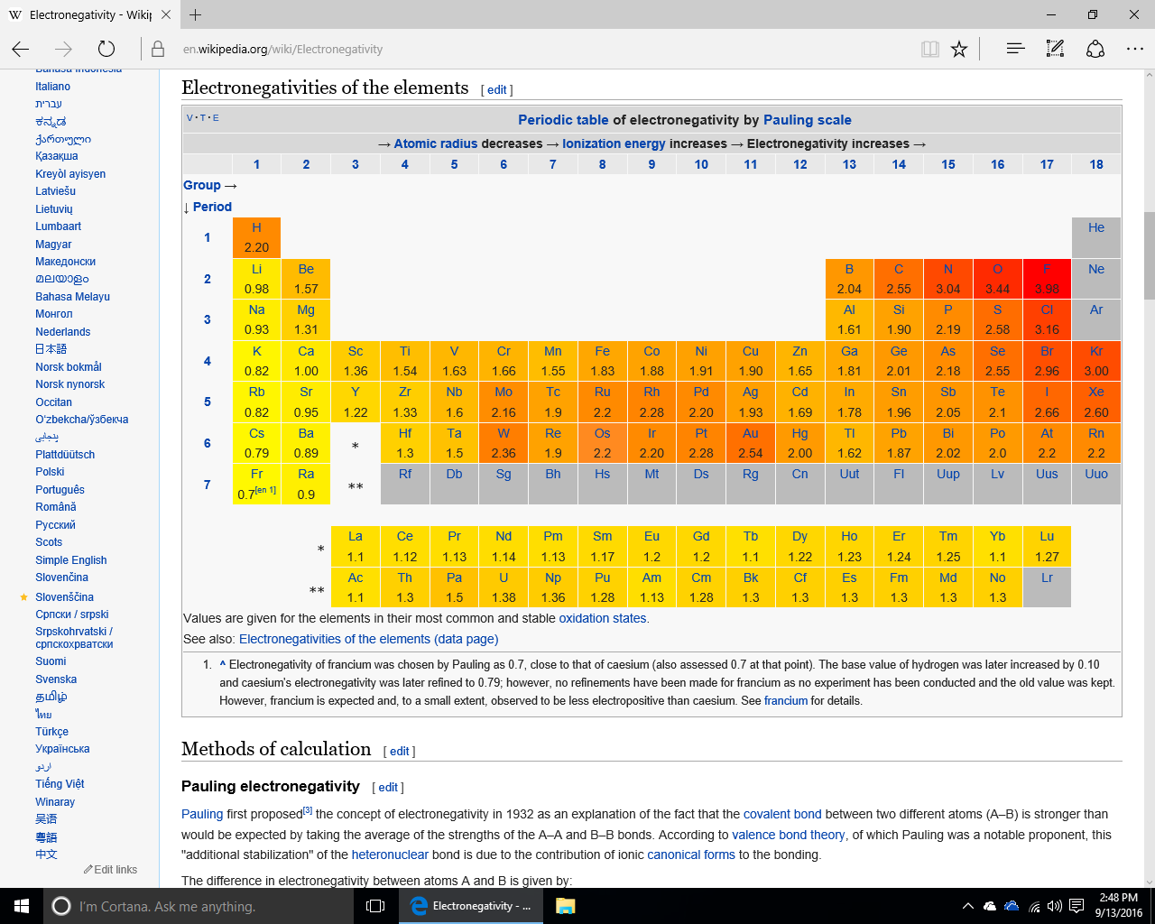

**Molecular Shape**

|  |  |  |  |
| --- | --- | --- | --- |
| **Number of**  **Electron Groups** | **Number of**  **Lone Pairs** | **Electronic Geometry** | **Molecular Geometry** |
| 1 | 0 | linear | linear |
| 2 | 0 | linear | linear |
| 3 | 0 | trigonal planar | trigonal planar |
| 3 | 1 | trigonal planar | bent (angular) |
| 4 | 0 | tetrahedral | tetrahedral |
| 4 | 1 | tetrahedral | trigonal pyramidal |
| 4 | 2 | tetrahedral | Bent |
| 5 | 0 | trigonal bipyramidal | trigonal bipyramidal |
| 5 | 1 | trigonal bipyramidal | see-saw |
| 5 | 2 | trigonal bipyramidal | T-shaped |
| 5 | 3 | trigonal bipyramidal | linear |
| 6 | 0 | octahedral | octahedral |
| 6 | 1 | octahedral | square pyramidal |
| 6 | 2 | octahedral | square planar |

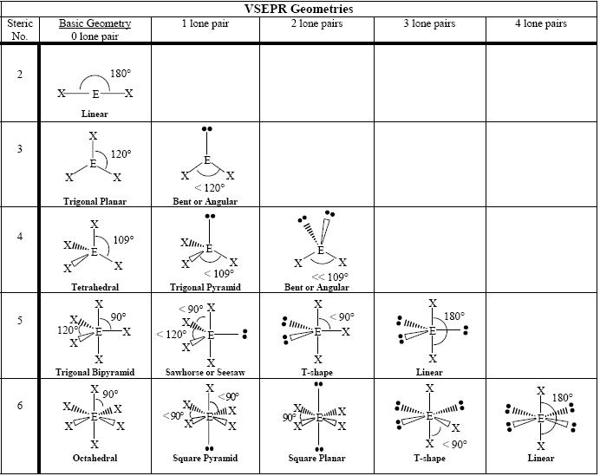

From https://commons.wikimedia.org/wiki/File:VSEPR_geometries.PNG